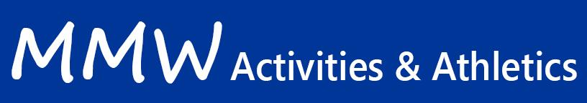

The Hub Club- Inspired the Minnetonka Foundation’s “THE HUB”

Description:
The MMW “Hub Club” is a Makerspace environment which will be defined by students’ interest and passions. Learn how making and coding can collide or simply make or code. Students will have access to our Maker Bot Replicator+ 3D printer, a Cricut Maker, Apple Computers (for those interested in learning more about Apple Apps), a variety of robots, Conductive Thread and other many other materials. Students will engage in small projects that may involve making or programming for the benefit of our school for example drawing and printing Minnetonka M cookie cutters to be sold for a fundraiser, making Ugly Holiday sweaters for teachers, or coding an MMW App. Please bring your creative spirit and open mind!

Schedule | Every Monday & the 1st and 3rd Thursday of each month from 8:15-9:00 starting on Monday Sept. 18th.
Location | MMW Media Center
Fees | $50 Participation Fee and $10 Supply Fee. (Note: The Participation Fee is paid only once per year for as many activities as a student wishes to participate.)
Advisor(s) | Lisa Reed- Lisa.Reed@minnetonkaschools.org
Registration Deadline | Ongoing until full

